=====================================================================================
REDUCED 11/29/18
PRICE | $66,900
Showing Instructions | Vacant Show Anytime Notify Office
Property Address | 301 St Petersburg St. Robinson, IL 62454
Owner | Equity Trust Company Custodian FBO Gerald Getlz & IRA Club FBO Colling Getlz
Listed By | James Fiscus

Property Type | Rambler
Sq Footage | 1,052
# Of Floors | 1
Exterior | Vinyl
Roof | Shingle New ‘17
Bedrooms | 3
Baths | 1.5
Foundation | Conc. Block
Basement | Partial
Lot Size | 60’ X 120’
Garage | None
Heat | FA New ‘17
A/C | CA New ‘17
Approx. Age | ±1930
Water | City
Sewer | City
School Dist. | Robinson
Tax I.D. | 05-4-03-010-051-000
Taxes (Yr) | $1,007.38
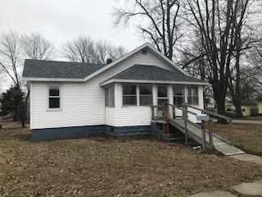
Additional comments:
Move in ready home located just a couple of blocks from Robinson City Park! This home over the last year has had a new roof, guttering, FA, CA, sewer line, and replacement windows. The kitchen and full bath were both completely remodeled and the current owners added a ½ bath to the home. The home was also repainted and a load of gravel was brought in by the driveway. The laundry is located in the basement which is almost a full basement. If you want a move in ready home look no further this is the home for you!

Living Room | 11’ X 17’6” | Bedroom | 10’6” X 8’6”
Kitchen | 14’ X 11’ | Bathroom | 7’ X 5’6”
Dining Room | 12’ X 12’6” | ½ Bath | 6’ X 4’
Bedroom | 13’6” X 9’ | Enclosed Front Porch | 17’6” X 6’6”
Bedroom | 10’6” X 9’6”
R2.25 All information believed to be correct, but not guaranteed.

